56

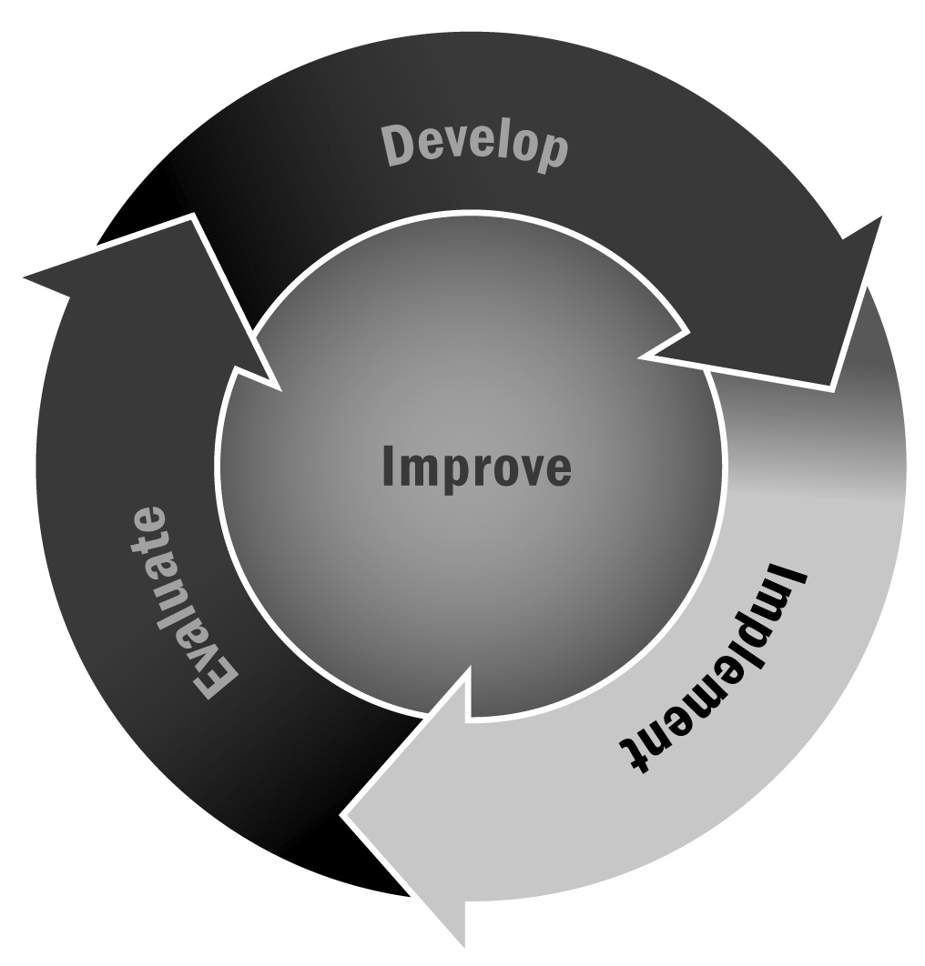
Volunteer Form
In Chapter 3, you learned about the importance of involving families, community members, and other stakeholders in program planning and delivery. Having volunteers join your program can be a rewarding experience for everyone.
Directions: Use this form to learn more about individuals who are interested in volunteering with your program.

Dear Volunteer,
Volunteers are extremely valuable components of our program, and acting as a volunteer is a great way to learn more about what goes on in our program and to help support the program and school. Because of the tremendous impact that volunteers can have on young people, we believe that all volunteers should possess the following personal characteristics.
[Program Name] volunteers must:
- Enjoy working with young people
- Feel that being a volunteer is an important position, worthy of your time and effort
- Be willing to work with youth in a variety of situations
- Accept the responsibility that goes along with your position
- Be of good and reliable character
If you are interested in being a volunteer, please fill out the remainder of this form and return it to [Name].
Your name:
Address:
Email:
Telephone:
Do you have a child in this program?

- Please tell us why you would like to volunteer with our program.

- How would you like to volunteer? (Check all that apply.)
❒ | Teach a class or activity with youth |  | ❒ | Join the family advisory group
❒ | Help a staff member with a class or activity with youth |  | ❒ | Join the organization/program advisory board
❒ | Greet young people and answer questions |  | ❒ | Help with paperwork and other administrative tasks
❒ | Teach a class or activity with adults |  | ❒ | Support fundraising efforts
❒ | Help a staff member with adult programming activities |  | ❒ | Help market the program (e.g., write for the newsletter, pass out flyers)
❒ | Other, please specify:

- Are there specific content areas, skills, or competencies that you could contribute to our program?
 | Academic content areas
❒ | English language arts |  | ❒ | Science/science, technology, engineering, math (STEM)
❒ | Math |  | ❒ | History/social studies
 | Homework help |  |  | Social and emotional well-being
 | Tutoring |  |  | Sports
 | Computer/technology skills |  |  | Physical fitness
 | Creative arts |  |  | Service learning
 | Healthy living |  |  | Cultural appreciation and diversity
 | Other, please specify:

- Please indicate when you would be available to volunteer with the program.
 | Sun | Mon | Tue | Wed | Thu | Fri | Sat
From:
To:
Exceptions:

- Please provide the name and contact information (e.g., phone number, email address) for two references.

